Aim: To create a data report analysis using data-profiling

Code:
import pandas as pd
from ydata_profiling import ProfileReport

# Load dataset
df = pd.read_csv("Untitled.csv")

# Generate EDA report
ProfileReport(df, title="Game Dataset EDA Report", explorative=True).to_file("game_eda_report.html")

Output:

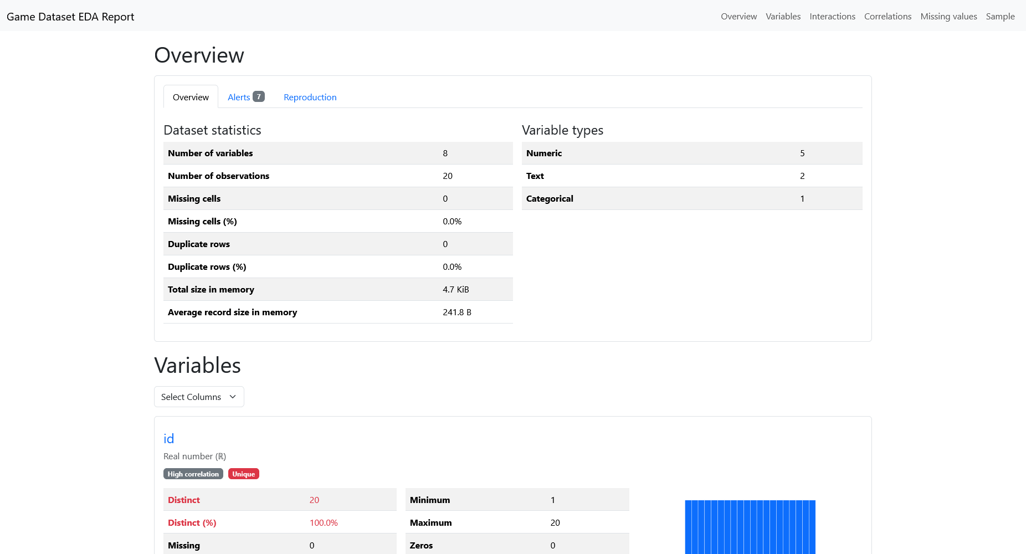

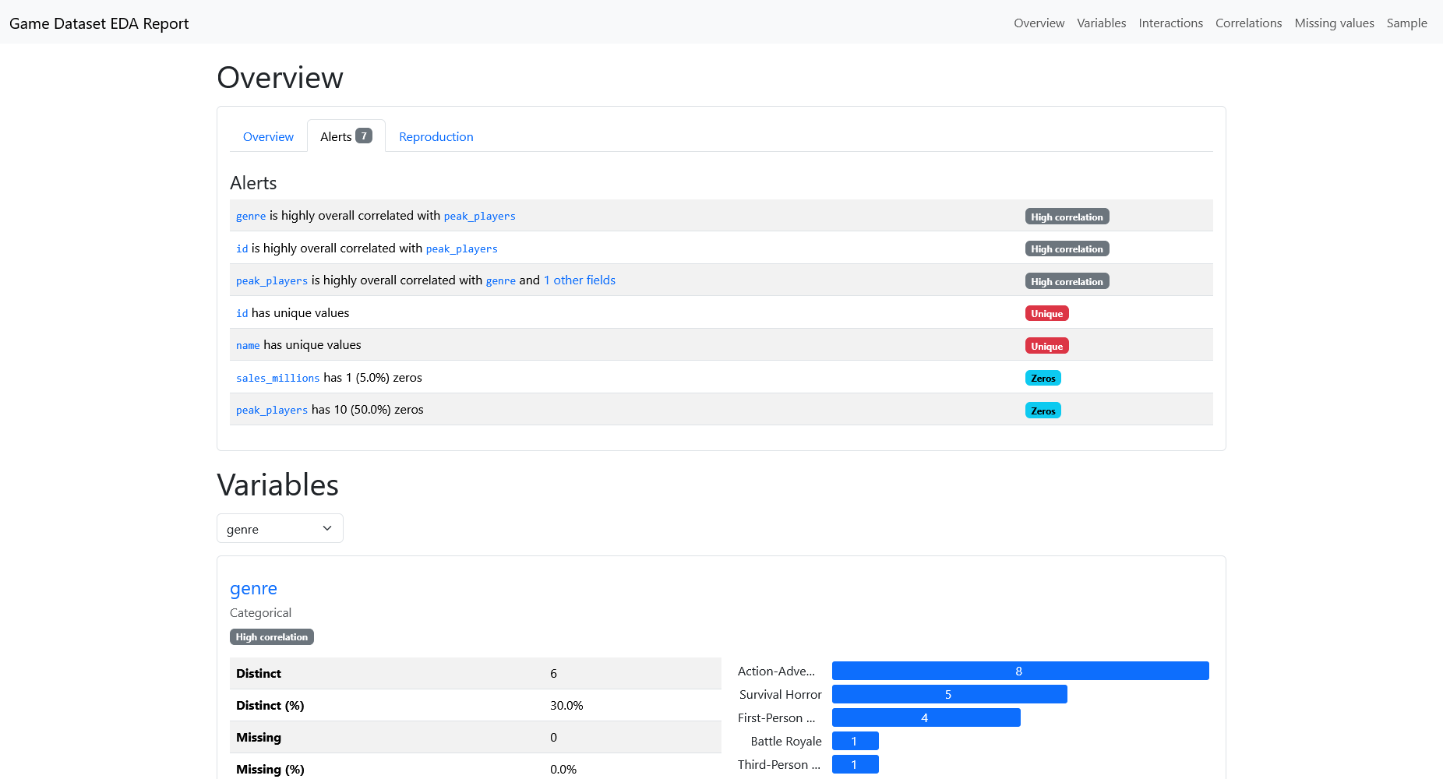

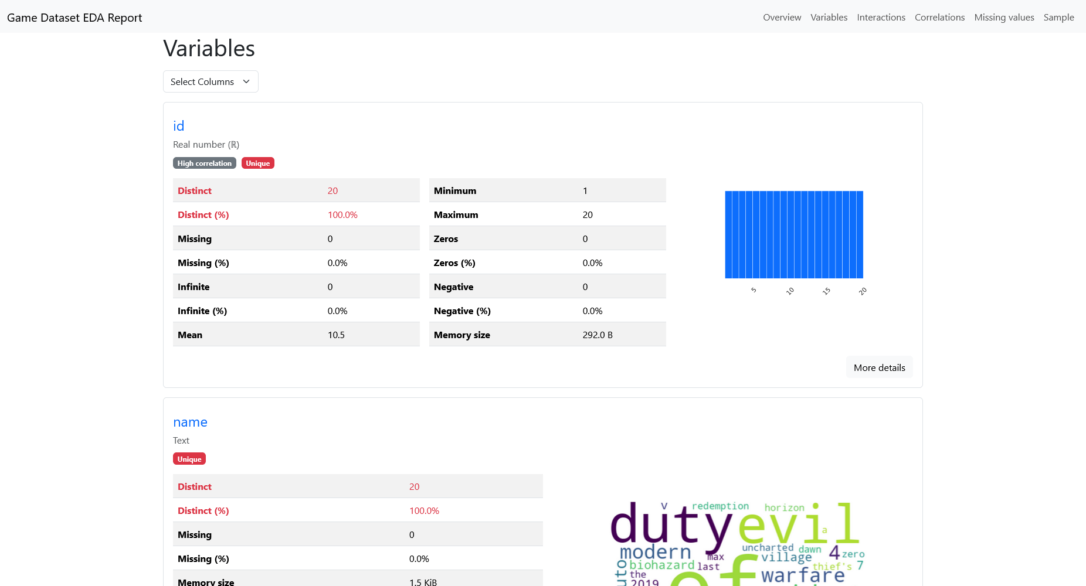

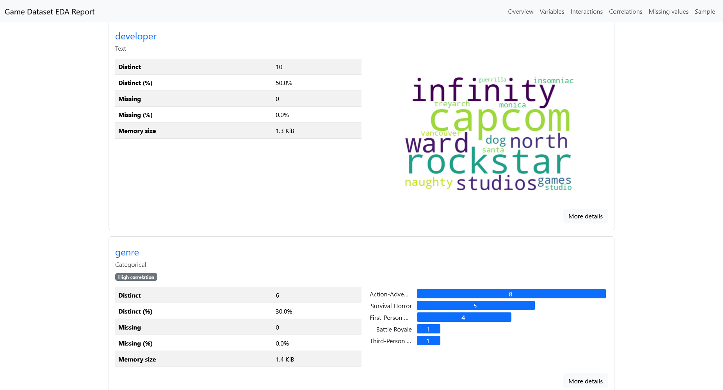

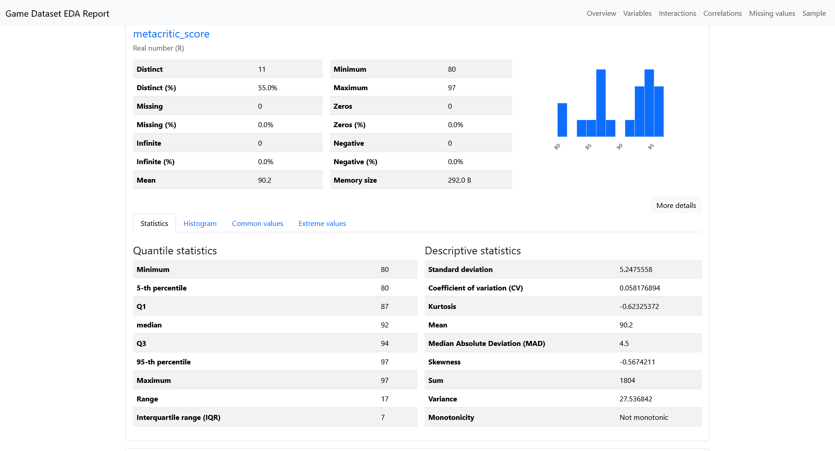

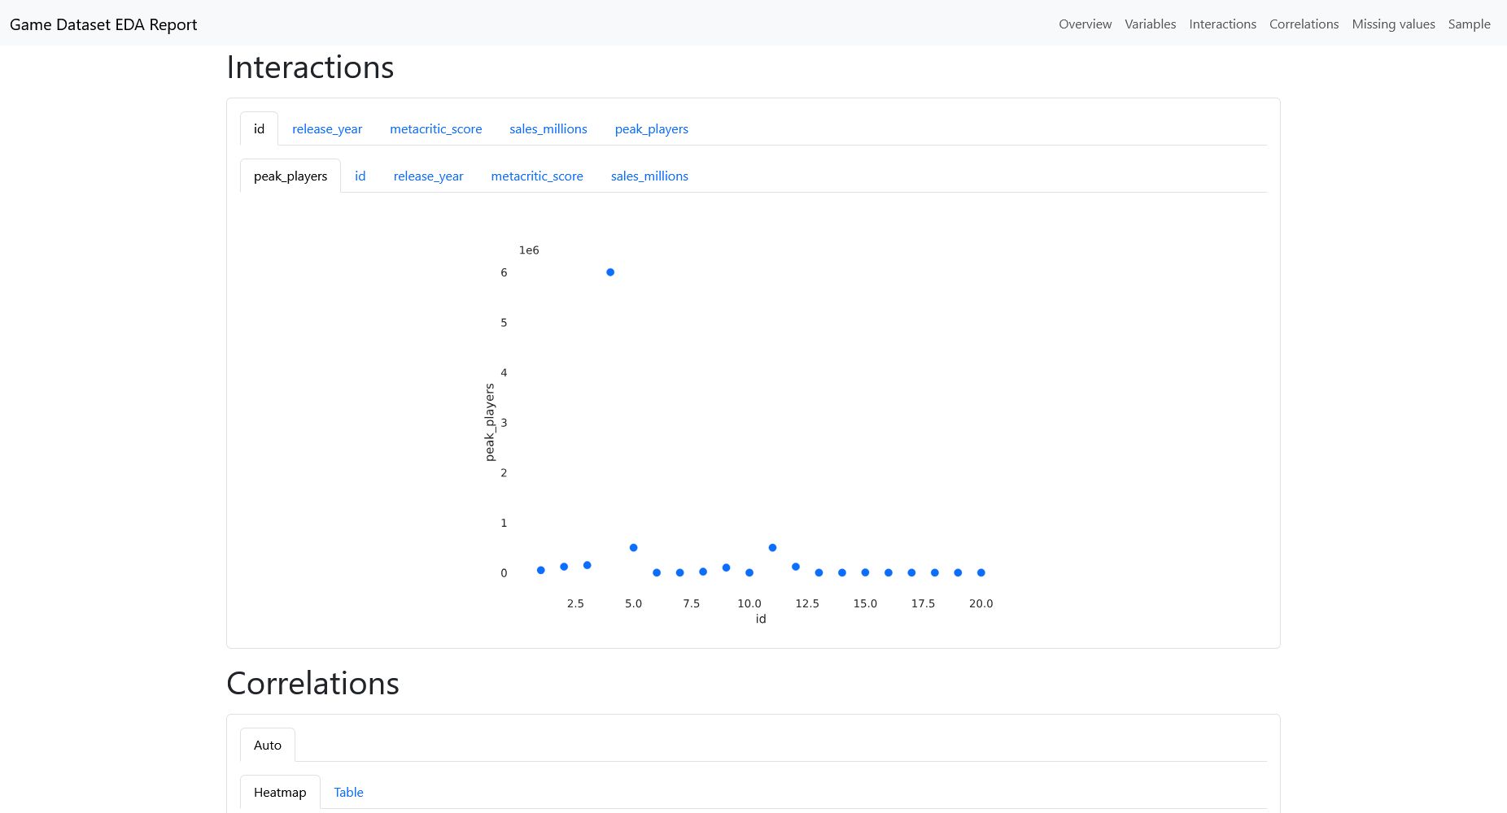

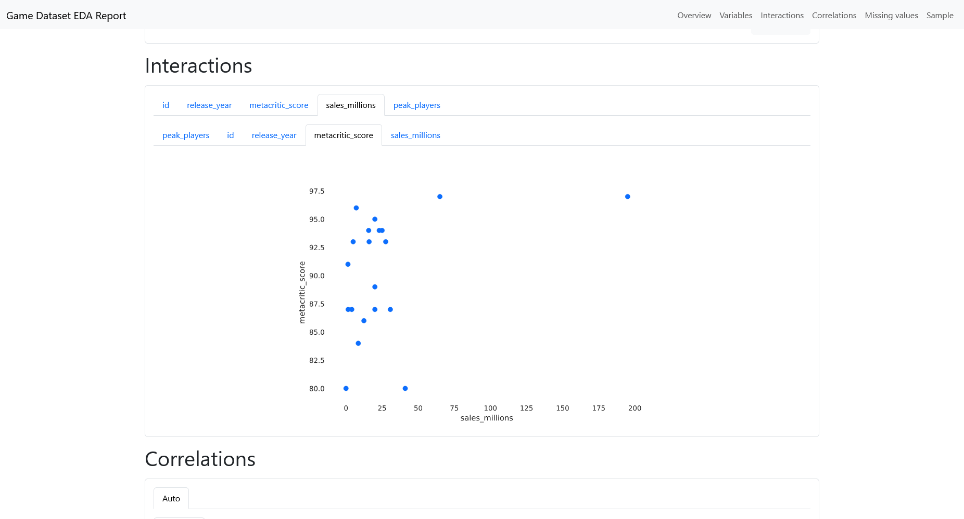

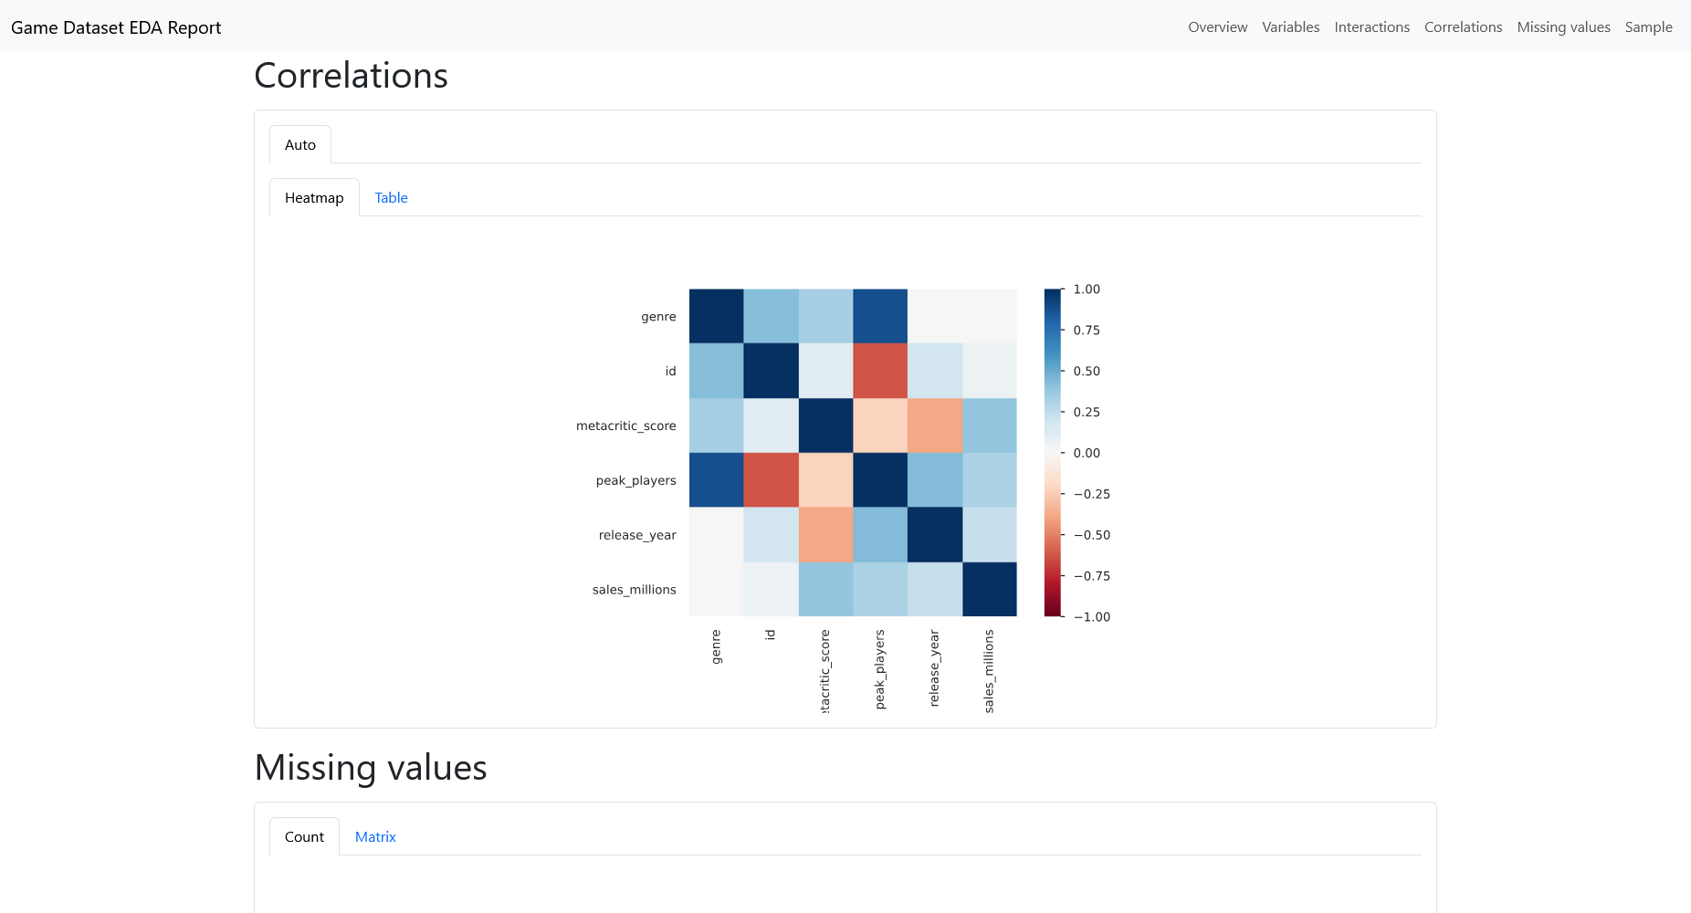

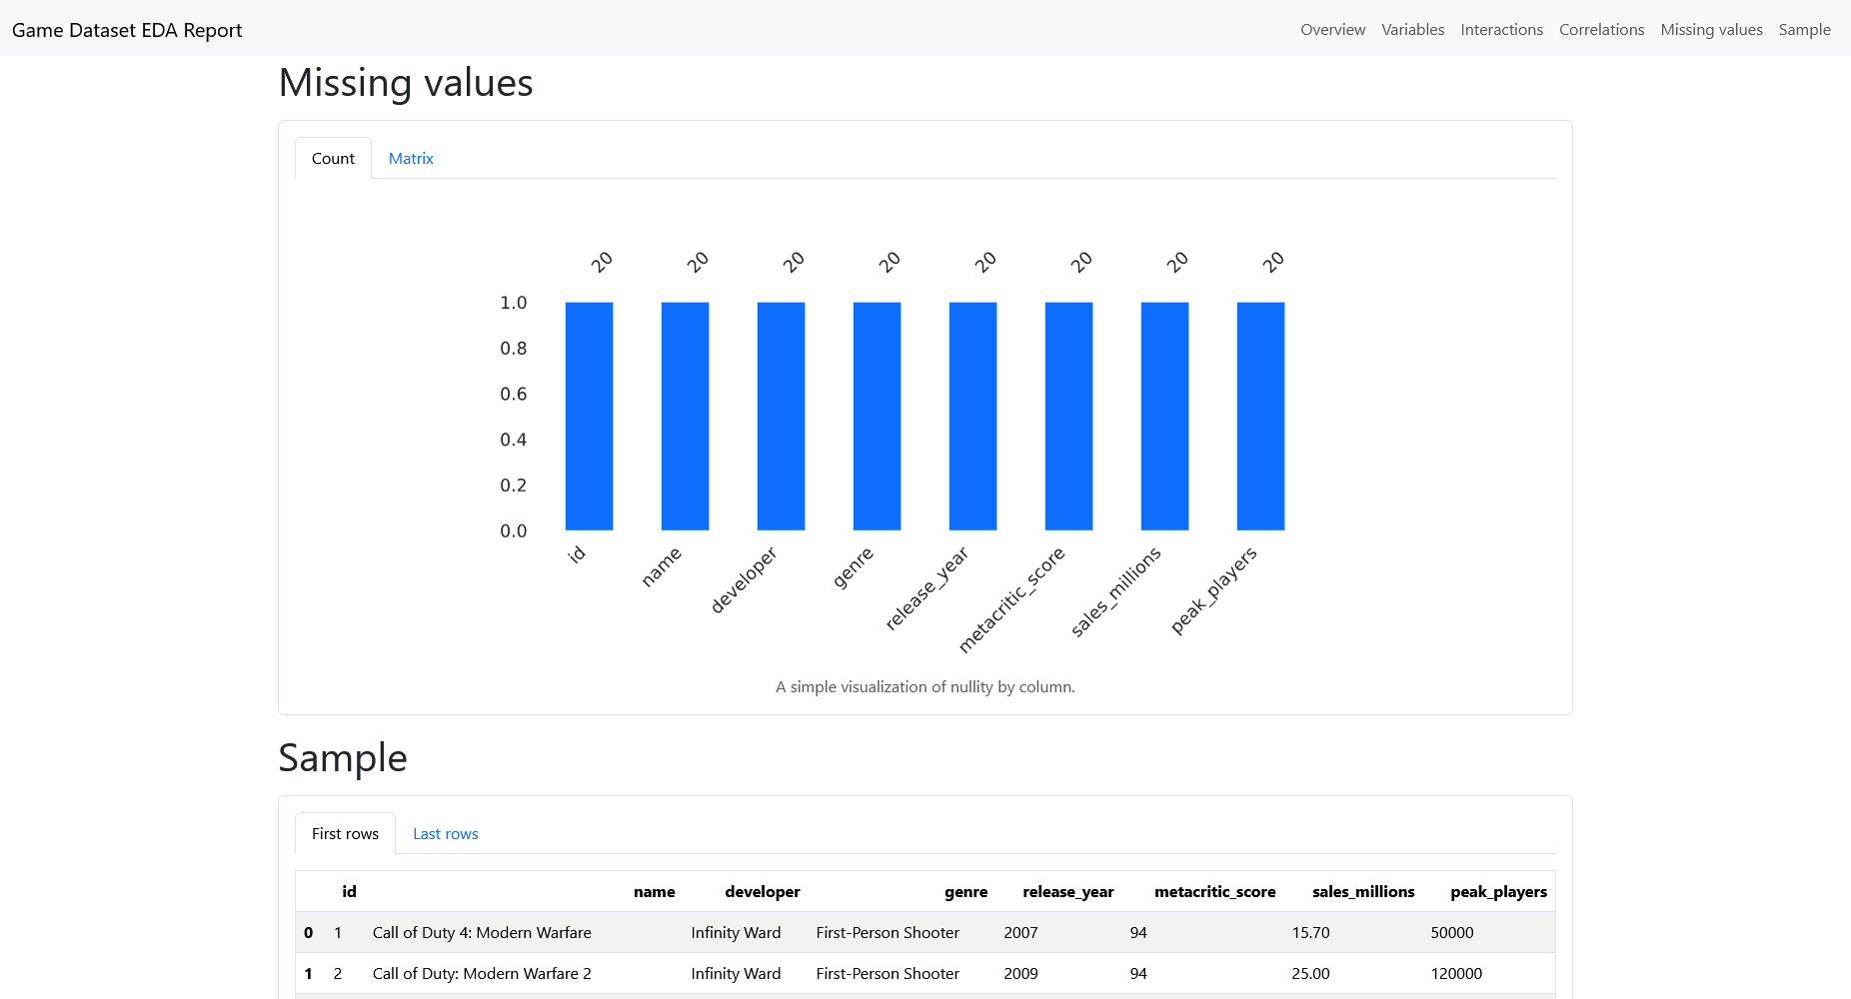

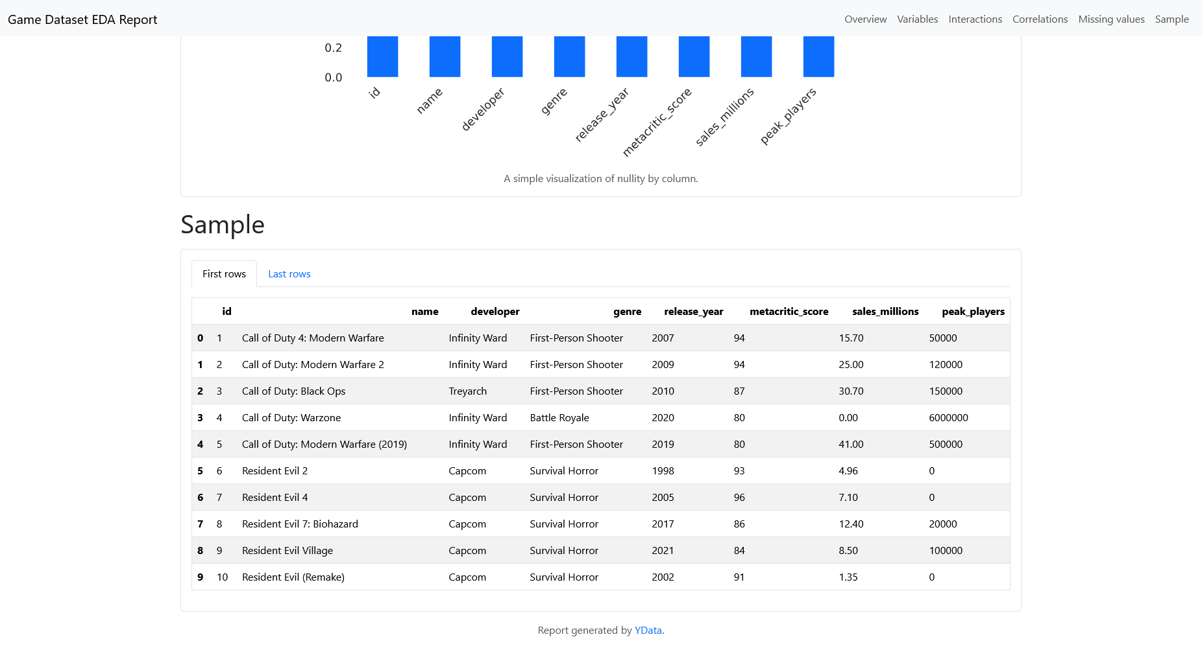

Overview: The dataset has 20 game entries with 8 complete variables and no missing data.
Variables: `id` and `name` are unique identifiers, while `developer` shows moderate variety.
Variables: `genre` is categorical, with Action-Adventure and Survival Horror being the most common.
Variables: `metacritic_score` ranges from 80 to 97, with an average of 90.2.
Variables: `sales_millions` varies significantly, including one game with zero sales.
Variables: `peak_players` has many zeros and one extreme high value of 6 million.
Interactions: The analysis will explore relationships between variables like sales and player count.
Correlations: High correlations are noted for `id` and `peak_players` with other variables.
Missing values: The dataset is complete with zero missing values across all columns.
Sample: The first ten rows show a focus on Call of Duty and Resident Evil franchises.

Conclusion
Successfully create a data report analysis using data-profiling.

